Ajay kumar

Rahul

Neeraj Yadav

Ravi

**Under Supervision of**

**Internal: Mr. Ravinder beniwal**



**Value fresh**

# INTRODUCTION

With the rise of online grocery shopping, users often struggle with **finding specific items, and receiving personalized recommendations**. This project aims to solve these challenges by integrating **AI-powered image search, analysis items.** Additional****

**3**

**OBJECTIVE**

•

Develop an AI

-

powered image search

feature to help users find similar grocery

items.

•

Provide real

-

time analysis of food items

within different cities.

•

•

Implement a chatbot for quick and

efficient customer support.

# METHODOLOGY

**1.Data Collection:** Gather and categorize general store inventory, including images, descriptions .

**2.AI Model Training:** Utilize machine learning algorithms to develop image-based search, prediction, and demanding items .

**3.Feature Development:** Implement AI-driven search, personalized recommendations, trend tracking, and chatbot functionalities.

**4.Testing & Refinement:** Conduct usability testing to optimize accuracy and user experience.

# EXPECTED OUTCOMES

•A seamless and efficient online general items experience.

•Higher user engagement through real-time tracking and personalized suggestions.

**7**

•Increased customer satisfaction with quick AI-driven items recommendations.

•Improved customer service response time using an automated chatbot.

•A scalable platform that can be adapted for general stores of all items.

**APPLICATION**

•

AI

-

enhanced e

-

commerce platforms for general items and food cart

-

•

Data

-

driven insights for grocery store owners to optimize inventory and

pricing.

•

Smart customer support via AI

-

powered chatbots.

•

Demanding items prediction for sustainable at lowest prices.

-

.

**8**

# CHALLENGES AND LIMITATION

•**Data Accuracy** – Ensuring high-quality product images and descriptions.

•**AI Integration** – Seamlessly implementing image search and recommendations.

**9**

•**Scalability** – Handling large user traffic and database efficiency.

•**User Adoption** – Making AI-driven features intuitive and useful.

•**Real-Time Performance** – Delivering fast and accurate results.

•**Cost Constraints** – Managing AI infrastructure and hosting

**FLOWCHART**

**10**

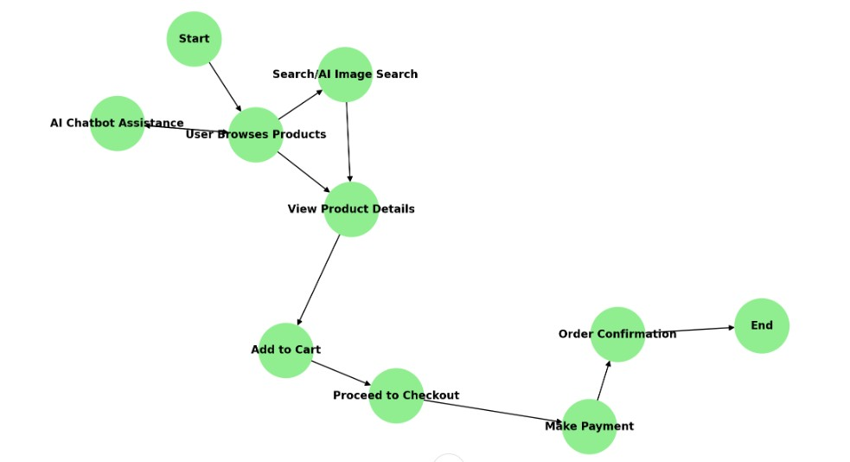

**11**

# CONCLUSION

• This AI-powered general store enhances with **smart image search, dynamic marketing and personalized recommendations**. By integrating AI-driven features and seamless backend support, it ensures **efficient product discovery and customer engagement**. Despite challenges like **data accuracy and scalability**, the platform aims to provide a **sustainable, user-friendly, and future-ready general store shopping experience**.

**THANK**

**YOU**